Comparison Essay Sarah Pritchard

Historical

This is an advert from circa 1920s-1930s for Savage Lipstick, an American brand. The artwork is by Frank Farkas, an artist who upon further research seems to be an etching artist from the time. As such I presume that is how this illustration was created.

As for the style of the image, it is clear it has been influenced by the Art Deco movement which was at its peak around the early ’30s. No doubt the use of this style was to seem hipper and trendier and convince more people to buy the product. As after all they are not just selling a lipstick, they are selling an image, of the glamorous young lady which women of this period aspired to be. In the back of the image you can also see a palm tree, given the boom in cruise holidays and the allure of the exotic this was included to express that by using this product you could become this “exotic” woman. Again, feeding into this idea of glamour in the interwar years, no doubt helped by the new disposable income of the average middle and upper-class household.

​The image has a lot of rich purples, red and pinks. It can be extrapolated that the use of red and purple is to symbolise wealth, royalty and desire; making the product seem more exclusive and stylish. Whereas the pinks would have been used as the delicate feminine, very much helping to reinforce the stereotype of women during this era.

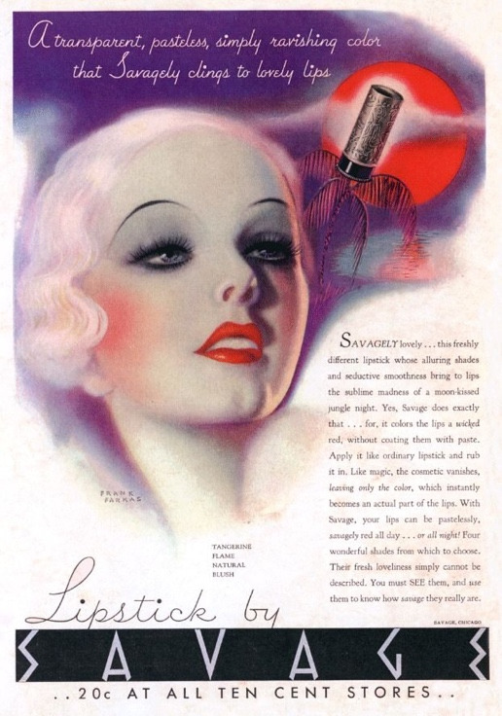
Though the product is featured in this advertisement the actual stick is just plonked on the edge, whereas the real focus is on the lips which are front and centre in a bright red. No doubt a conscious decision on the advertiser's part as the main selling point of the advertisement is the effect the product will give you and not the actual physical product itself.

The language in this advert is again very dramatic and descriptive with the use of alliteration “seductive smoothness bring to the lips sublime madness of moon-kissed jungle night.” The advertisement is using sex appeal to sell the product. Something that is a trend with lipstick adverts throughout the decades, particularly with red lipsticks. Again, this is a lot to do with the psychological connotations of red with sex and desire.

The brand logo is in-keeping with the style of the advert, sporting an Art Deco logo font. Accompanied by a script handwriting font for the basic description, used to imply that these are the model’s own notes on the product. Meanwhile, the main body of the text is in a very standard easy to read serif font.

Contemporary

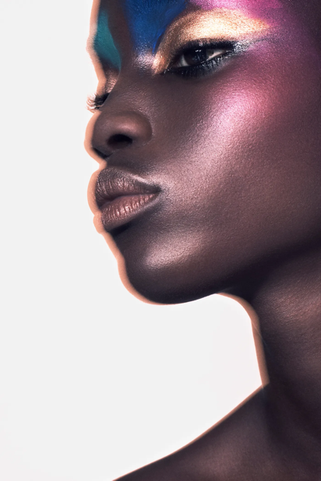
This is a photo advert for Zara Beauty’s Eco-conscious line from 2021. The product though not physically shown is being demonstrated on the model. The styling of the makeup in this expressive editorial fashion would indicate that the company is marketing this product as a high-brow professional item. As such, the target audience of this product is the professional makeup artist as opposed to the regular everyday persons.

The main focal point of this advert is the model in the middle. Upon further research, the company specifically chose to include models of all ethnic backgrounds as a direct response to the lack of diversity seen from some makeup brands. Something a lot of brands are starting to do. The makeup itself is marketed as being the companies first completely vegan, clean, eco-conscious and universal line. Most likely a response to the growing social concerns over climate change and the own individual impact of the customer on the environment.

Meanwhile, the image itself has quite a warm colour palette, accented by the cool green and blues above the eyes. I believe the reason for this is that warm colours typically have an inviting and happy presence to them, linking back to psychological colour theories. The blue and green accents create contrast and depth as they are complementary to the pinks and golds.

Comparison

Upon looking at each advertisement one of the most obvious differences between the two is the ethnicity of the models themselves. This has a lot to do with the social environment in which both were published. Going back to the Tudors, beauty has always been defined by having a fair complexion. This was seen as a mark of someone privileged enough that they did not need to work all day out in the sun. This is something that persisted up until the middle of the 20th century whereby “tanning” started to become fashionable. It is for this reason I believe the advert from the 1930s features a very white woman. Something that is in sharp contrast to the advertisement from 2021, whereby social attitudes about race and complexion have changed dramatically to a point where all skin tones are celebrated and praised as symbols of beauty.

Another difference between the two advertisements would be how they are marketed. The modern advert has a clear consideration of the impact of the product on the environment. Something very much fuelled by the growing societal concerns over climate change. By including this element about the product, it convinces more environmentally conscious individuals to buy the product. The only problem is that this is not stated in the advertisement and only becomes apparent when you look into the product. Meanwhile, the historical advertisement features no such concerns. If anything it actively encourages the opposite with its promotion of travel. Evident from the language in the text “moon-kissed jungle night” and the subtle inclusion of the palm tree and sunset in the background.

The lack of text is also another significant difference between the two adverts. This is most likely because modern advertisements have steered away from big blocks of text in favour of visual communication. This is a result of the fast-paced world of today and a result of the sheer bombardment of adverts faced daily. Something which has contributed to a low tolerance of adverts by the general viewer. Modern adverts need to make an impact fast and a massive block of text will do nothing but put people off from buying the product. From this, it could be inferred that consumers of the past had more time to read advertisements.
Bibliography

Bladt, M., 2021. Zara Beauty: Zara is launching an eco-conscious makeup line. [online] Vogue Paris. Available at: <https://www.vogue.fr/beauty-tips/article/zara-beauty-makeup-line-2021> [Accessed 30 November 2021].

loveexploring.com. 2019. The incredible story of how cruising has changed from Titanic to today | loveexploring.com. [online] Available at: <https://www.loveexploring.com/gallerylist/84317/the-incredible-story-of-how-cruising-has-changed-from-titanic-to-today> [Accessed 30 November 2021].

Make-up: A Glamorous History, 2021. [TV Program] BBC Two: BBC

